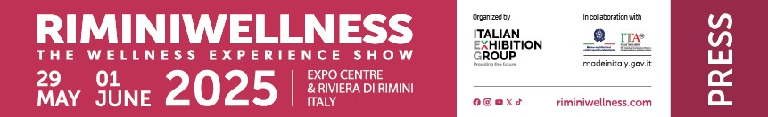
press release
(English translation)

RIMINIWELLNESS: THE INTERNATIONAL EVENT FOR WELLBEING
- The ticket office for the 19th edition, scheduled from May 29 to June 1, 2025, officially opens on December 6
- Six areas and a host of new features anticipated for the international wellness and fitness event
- Major spotlight on sports medicine, physiotherapy and rehabilitation sciences for fitness and health professionals

Rimini (Italy), 5 December 2024 - The 19th edition of RiminiWellness, the international reference event for the world of wellness and fitness, will return to the spaces of Rimini Expo Centre and places along the Riviera from 29 May to 1 June 2025. Organised by IEG - Italian Exhibition Group, the event is an iconic get-together for the entire wellness community, combining innovation, business, training and entertainment in a collective celebration of health and well-being.
ALL THE VARIATIONS OF WELLNESS UNDER ONE ROOF
RiminiWellness is not merely a trade fair, it is an authentic international hub that encompasses the entire universe of wellness and fitness spread across 190,000 square metres of indoor and outdoor exhibition space. The main industry players all gather under one roof: from manufacturers of exercise equipment, world leaders in their field, to gyms and trade associations, increasingly driven towards technological innovation and new training methods. There will a host of health professionals focusing on sports medicine, rehabilitation, physiotherapy and longevity, as well as nutrition professionals, with nutraceutical and supplement products that combine physical well-being with personal care. Complementing the event are activities related to tourism and design, increasingly connected with the world of wellness, and the areas dedicated to technical clothing and lifestyle. With a total of 30 exhibition halls, RiminiWellness will offer diversified experiences, designed to meet the needs of professionals, companies and visitors, creating a unique meeting, training and inspirational place.
THE SIX AREAS OF RIMINIWELLNESS 2025: A COMPLETE JOURNEY INTO WELLNESS
Once again, the 2025 edition of RiminiWellness will be organised into six different thematic areas, designed to satisfy every need and interest related to the world of wellness and fitness. The beating heart of the event is the ACTIVE area, where visitors can explore the latest training trends through masterclasses, live demos and meetings with world-famous trainers. The adrenaline-pumping STEEL area will again be a crowd-puller, with over 13,000 square metres dedicated to strength and performance disciplines. Body-building, Power-Lifting, combat sports, martial arts and body culture will be a unique fusion, complemented with a deep dive into the role of supplements, endorsed by the main industry brands. On the opposite side of the expo centre, lies the FITNESS area, an exclusive showcase for technological innovations, top fitness equipment, digital services and solutions for gyms, spas, medical and sports centres. The HEALTH area will be dedicated to health and longevity: in the upcoming edition there will greater emphasis on sports medicine, physiotherapy, rehabilitation sciences and professional training, with the development of nutraceuticals, a fast-growing industry thanks to its implications in the wellness and medical fields of interest for both the consumer and professional operators. For those looking for a more complete experience, the WELLNESS area will offer a 360° journey into personal well-being, with products, services and technologies designed to improve the quality of life. The theme of nutrition will be at the centre of FOODWELL, an even larger space that will host the latest news on healthy food, cooking demos, tastings and courses dedicated to a healthy lifestyle.
RIMINIWELLNESS OFF, ENERGY AND MOVEMENT IN AN AMAZING LOCAL AREA
The RiminiWellness OFF event, organised in collaboration with the Municipality of Rimini, will definitely be back in 2025: a Wellness Community Activation with a bunch of initiatives integrating wellness and movement among the historical, cultural and tourist sites of Rimini. From the coast to the city parks, from the Waterfront to the stunning Piazza sull'Acqua, the event celebrates accessible and inclusive wellness, strengthening Rimini's role as a promoter of an active lifestyle. In its third edition, RiminiWellness OFF will once again strive to involve a wide and varied public, from children to adults, from amateurs to athletes, making wellness an experience accessible to everyone.
TICKETS AVAILABLE FROM 6 DECEMBER
Get your ticket! Tomorrow, December 6 is the official opening of the online ticket office for the 2025 edition. All information on www.riminiwellness.com.
ABOUT RIMINIWELLNESS 2024
Date: 29 May – 1 June 2025; type: international show; organiser: Italian Exhibition Group S.p.A.; recurrence: annual; edition: 19th; open to: general public and operators; info: www.riminiwellness.com

PRESS CONTACT ITALIAN EXHIBITION GROUP
head of corporate communication & media relation: Elisabetta Vitali
press office manager: Marco Forcellini, Pier Francesco Bellini | press office coordinator: Luca Paganin | international press office coordinator: Silvia Giorgi | press office specialist: Mirko Malgieri; Nicoletta Evangelisti | media@iegexpo.it

MEDIA AGENCY RIMINIWELLNESS
Naper Multimedia| Zoe Perna | T. +39 02 97699600 | zoe.perna@napermultimedia.it | staff@napermultimedia.it

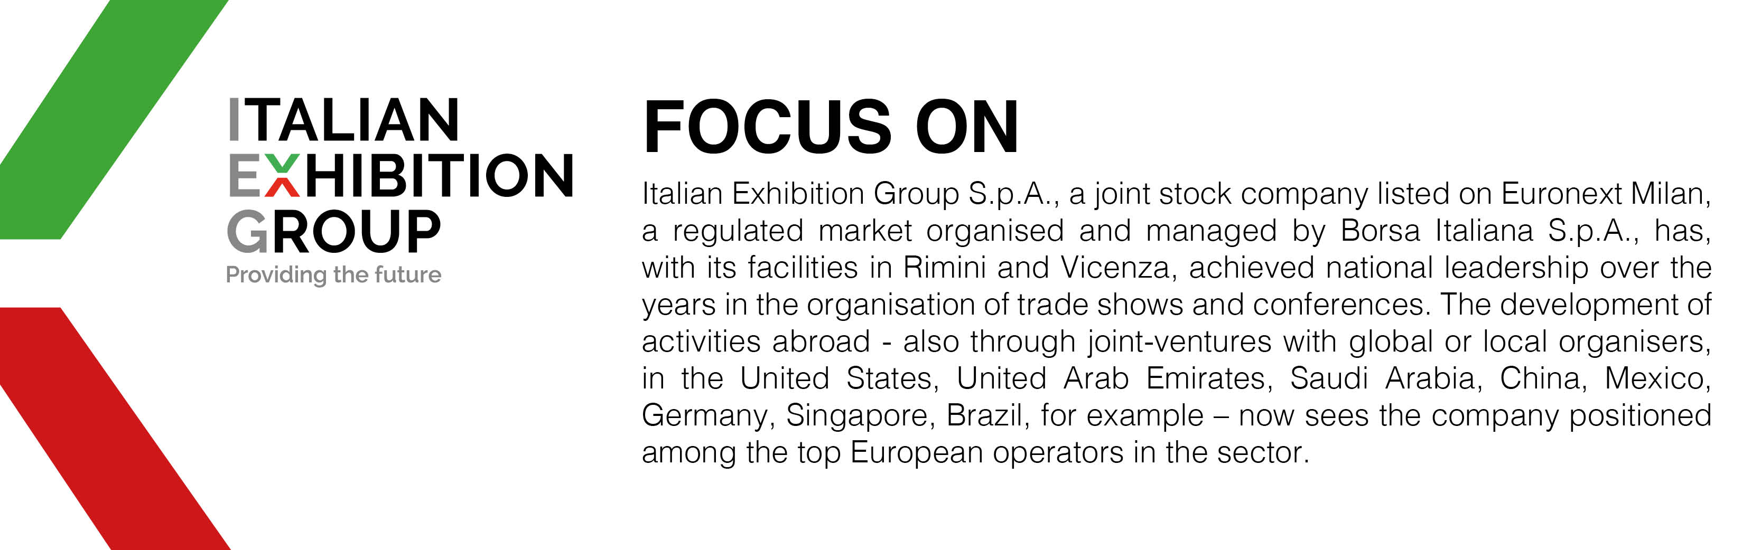

This press release contains forecast elements and estimates that reflect the management’s current opinions (“forward-looking statements”), particularly regarding future management performance, realization of investments, cash flow trends and the evolution of the financial structure. For their very nature, forward-looking statements have a component of risk and uncertainty, as they depend on the occurrence of future events. The effective results may differ (even significantly) from those announced, due to numerous factors, including, only by way of example: food service market and tourist flow trends in Italy, gold and jewellery market trends, green economy market trends; the evolution of raw material prices; general macroeconomic conditions; geopolitical factors and evolutions in the legislative framework. Moreover, the information contained in this release does not claim to be complete, and has not been verified by independent third parties. Forecasts, estimates and objectives contained herein are based on the information available to the Company as at the date of this release.

